THE PRESENT PERFECT – FORM
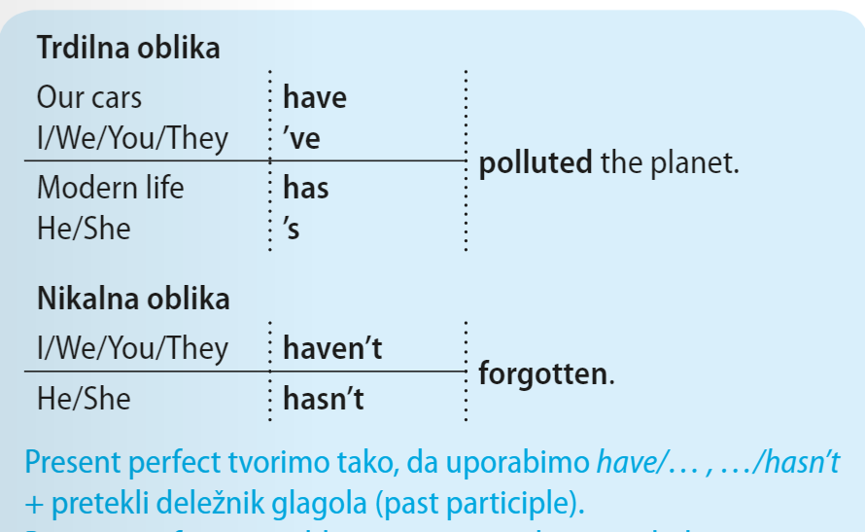 | ??? PRETEKLI DELEŽNIK???  Pretekli deležnik je pri nepr. glagolih “tretja gl. oblika”, --- taken, forgotten, sunk..  Pravilnim gl. pa dodamo končnico –ed.  Preprosta formula:  HAVE / HAS + V3

1V zvezek napiši naslov THE PRESENT PERFECT TENSE, nato pa zapiši kratko razlago (napisana je z modrimi črkami.)
Nadaljuj s spodnjimi vajami. NE PRINTAJ!!!

1. CHOOSE (Izberi.)
1 I have / has already finished my homework.
2 My son have / has just started the university.
3 The Black family have / has gone to the seaside.
4 Dad haven’t / hasn’t watered the plants.
5 Have / Has Sam ever been to the USA?
6 Our English teachers have / has never ridden a horse.
7 Ann, Frank and Jim have / has bought a new house.
8 Have / Has you taken the dog for a walk?
9 The weather have / has been terrible since yesterday.
10 My little sister have / has just stopped crying.

2. Complete the sentences using the past participle of the verbs in brackets.(dopolni povedi z ustreznim deležnikom.)
The train has ___________. We can go out now. (stop)
She isn’t ready. She hasn’t __________ her cases yet. (pack)
She has ___________ some photos. (take)
Sally hasn’t ___________ yet. Where can she be? (arrive)
I’ve never ____________ to your mother. (speak)
I haven’t ____________ which shoes to buy yet. (decide)
My father has ___________ to Rome. (drive)

3. Complete the sentences. Use the present perfect – positive or negative.(Tvori trdilne ali nikalne povedi.)
My mum isn’t at home now. She ___________________ (go) to the supermarket.
So far this month I ____________________ (see) three films.
I’m hungry. I __________________ (have) my lunch yet.
I ____________________ (see) Helen yet today. Is she at school?
Our football team ___________________ (win) all its matches so far this year.
I don’t know your boy-friend. I ________________ (meet) him yet.

