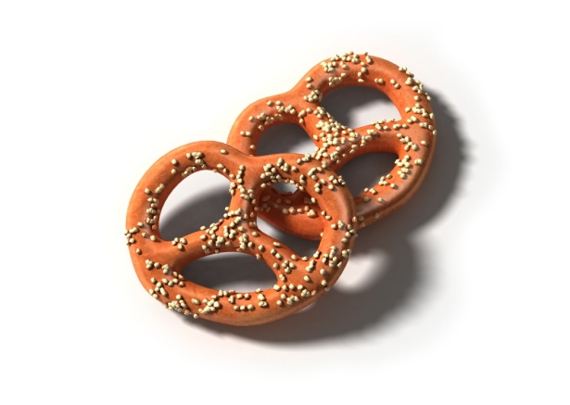d:\Documents and Settings\2A9.UPORABNI-7AC212\Local Settings\Temporary Internet Files\Content.IE5\CK2K1EJN\MC900334078[1].WMFd:\Documents and Settings\2A9.UPORABNI-7AC212\Local Settings\Temporary Internet Files\Content.IE5\CK2K1EJN\MC900334134[1].WMF NARIŠI ALI NAPIŠI !