- Odpri zvezek za angleščino in napiši z rdečo barvico naslov ANIMALS.
- Preberi opise in reši uganke. Izbiraj med spodnjimi rešitvami.
- Zadnjo poved vsake uganke prepiši v zvezek in jo oštevilči, kot v uganki.

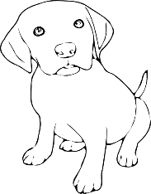
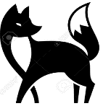
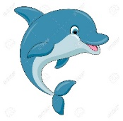
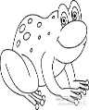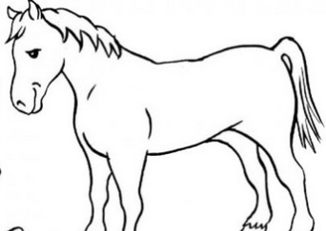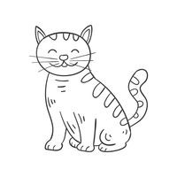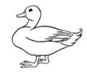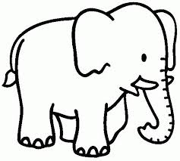
frog horse cat dog duck fox elephant dolphin

- I have four legs. I can run fast. I am black, white and brown. You can ride me. I say NEIGH, NEIGH. I am a ____________
- I have no legs. I can swim. I am blue. I have a big mouth. I live in the sea. I am a _______________.
- I have four legs. I can run, jump and bark. I am brown, white, black. I am your best friend. I say WOOF, WOOF. I am a _____________.
- I have four legs. I can run, jump, climb a tree and sleep.I am orange, black and white. I say MIAOW, MIAOW. I am a____________.
- I have two legs. I can walk, swim and fly. I am brown. I live in a pond. I say QUACK, QUACK. I am a________________.
- I have four legs. I am very big and grey. I can walk. I am an ______
- I have four legs. I can walk and run. I am orange. I like chickens. I live in the forest. I am a ______________.
- I have four legs. I can swim and jump. I am green. I live in the pond. I say RIBBIT, RIBBIT. I am a ____________.

SLOVARČEK
can (izgovoriš ken) – moči, znati I can = jaz zmorem
ride (izgovoriš rajd) – jahati You can ride me. = Lahko me jahaš.
say (izgovoriš sej) – reči I say = jaz rečem
live (izgovoriš liv) - živeti
bark (izgovoriš bark) – lajati
fly (izgovoriš flaj) – leteti
climb (izgovoriš klajmb) - plezati
pond (izgovoriš pond) - mlaka

